Sum of Min
Given an array of vertices V where V[i] represent the value of the i^{th} vertex. Also given pair of edges where u and v represent the nodes that are connected by an UNDIRECTED edge. The task is to find the sum of the minimum element in all the connected components of the given undirected graph. If a node has no connectivity to any other node, count it as a component with one node.
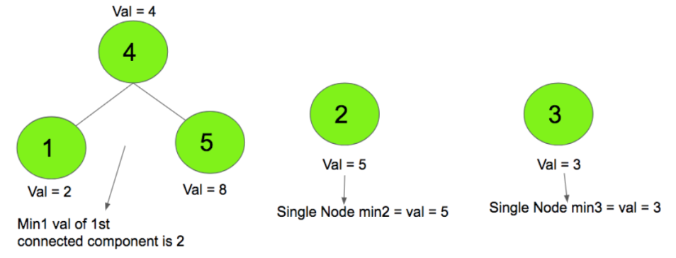
Output = 2 + 5 + 3 = 10
Input:
- |V| = from 4000 to 8000
- |E| = sparse or dense
- # components = from 1 to 100

Function to Implement
static int CalcSumOfMinInComps(int[] valuesOfVertices, KeyValuePair<int, int>[] edges)
SumOfMin.cs includes this method.
"valuesOfVertices": value of each vertex (vertices are named from 0 to |V| - 1)
"edges": array of edges in the graph (where key: sourceVertex, value: destVertex)
<returns> sum of the min value in each component of the graph

Example
vals1 = {0, 2, 5, 3, 4, 8 };
edges1[0] = new KeyValuePair<int, int>(1, 4);
edges1[1] = new KeyValuePair<int, int>(4, 5);
expected1 = 10;

vals2 = {0, 1, 6, 2, 7, 3, 8, 4, 9, 5, 10};
edges2[0] = new KeyValuePair<int, int>(1, 2);
edges2[1] = new KeyValuePair<int, int>(3, 4);
edges2[2] = new KeyValuePair<int, int>(5, 6);
edges2[3] = new KeyValuePair<int, int>(7, 8);
edges2[4] = new KeyValuePair<int, int>(9, 10);
expected2 = 15;

C# Help

Queues

Creation
To create a queue of a certain type (e.g. string)
Queue<string> myQ = new Queue<string>() //default initial size
Queue<string> myQ = new Queue<string>(initSize) //given initial size

Manipulation
- myQ.Count get actual number of items in the queue
- myQ.Enqueue(“myString1”) Add new element to the queue
- myQ.Dequeue() return the top element of the queue (FIFO)

Lists

Creation
To create a list of a certain type (e.g. string)
List<string> myList1 = new List<string>() //default initial size
List<string> myList2 = new List<string>(initSize) //given initial size

Manipulation
- myList1.Count get actual number of items in the list
- myList1.Sort() Sort the elements in the list (ascending)
- myList1[index] Get/Set the elements at the specified index
- myList1.Add(“myString1”) Add new element to the list
- myList1.Remove(“myStr1”) Remove the 1st occurrence of this element from list
- myList1.RemoveAt(index) Remove the element at the given index from the list
- myList1.Contains(“myStr1”) Check if the element exists in the list

Dictionary (Hash)

Creation
To create a dictionary of a certain key (e.g. string) and value (e.g. array of strings)
//default initial size
Dictionary<string, string[]> myDict1 = new Dictionary<string, string[]>();
//given initial size
Dictionary<string, string[]> myDict2 = new Dictionary<string, string[]>(size);

Manipulation
- myDict1.Count Get actual number of items in the dictionary
- myDict1[key] Get/Set the value associated with the given key in the dictionary
- myDict1.Add(key, value) Add the specified key and value to the dictionary
- myDict1.Remove(key) Remove the value with the specified key from the dictionary
- myDict1.ContainsKey(key) Check if the specified key exists in the dictionary

Creating 1D array
int [] array = new int [size]

Creating 2D array
int [,] array = new int [size1, size2]

Length of 1D array
int arrayLength = my1DArray.Length

Length of 2D array
int array1stDim = my2DArray.GetLength(0)
int array2ndDim = my2DArray.GetLength(1)

Sorting single array
Sort the given array in ascending order
Array.Sort(items);

Sorting parallel arrays
Sort the first array "master" and re-order the 2nd array "slave" according to this sorting
Array.Sort(master, slave);

